aPRBind: protein-RNA interface prediction by combining sequence and I-TASSER model-based structural features learned with convolutional neural networks

Yang Liu, Weikang Gong, Yanpeng Zhao, Xueqing Deng, Shan Zhang and Chunhua Li*

Faculty of Environmental and Life Sciences, Beijing University of Technology, Beijing 100124, China

*All correspondence should be addressed to Chunhua Li (E-mail: chunhuali@bjut.edu.cn)

Minimal-redundancy-maximal-relevance (mRMR)
First, we define the mutual information between two random variables x and y as
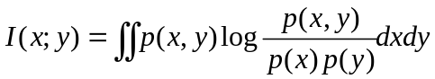, (1)
where p(x), p(y) and p(x,y) are their individual and joint probability density functions. In terms of mutual information, the purpose of feature selection is to find a feature set S with m features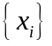, which has the largest relavence with the target class c. This scheme, called Max-Relavance, has the following form
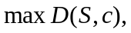 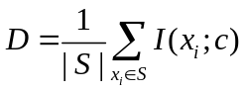, (2)
where D is the mean value of all mutual information values between individual feature x_{i} and class c. It is likely that features selected according to Max-Relevance could have rich redundancy, i.e., the dependency among these features could be large. When two features highly depend on each other, the respective class-discriminative power would not change much if one of them is removed. Therefore, the following minimal redundancy (Min-Redundancy) condition can be added to select mutually exclusive features
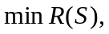 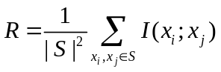, (3)
The criterion combining the above two constraints is called “minimal-redundancy-maximal-relevance” (mRMR) [1]. We define the operator 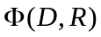 to combine D and R and consider the following simplest form to optimize D and R simultaneously
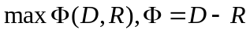 (4)

Accuracy estimation of I-TASSER structure models
The accuracy of the I-TASSER structure models is estimated through the calculation of the confidence score (C-score) of the structure assembly simulations [2]
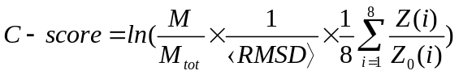, (5)
where M_{tot} is the total number of the I-TASSER structure decoys used in the clustering; M is the multiplicity of structures in the cluster; <RMSD> is the average RMSD of the decoys to the cluster centroid. These terms correspond to the degree of convergence of the structure assembly simulations. Z(i) and Z₀(i) are the highest Z-score of the templates by the ith LOMETS threading program and the corresponding Z-score cutoff for distinguishing between good and bad templates. The normalized Z-scores measure the significance of threading alignments and correlate with the quality of the LOMETS templates.
The large-scale benchmark tests show that there is a strong correlation between C-score and the accuracy of the I-TASSER models. The correlation coefficient between C-score and the actual TM-score is 0.91 and that between C-score and RMSD is 0.75. These data allow a quantitative estimation of the TM-score and RMSD of the first predicted model related to the native state
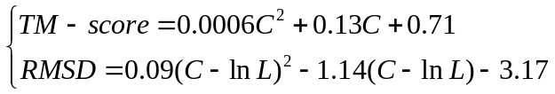 , (6)
where C is the C-score and L is the length of the target sequence. In a large-scale benchmark test on 500 non-redundant proteins, the average errors of quality estimation using Eq. (6) are 0.008 and 2.0 Å for TM-score and RMSD, respectively.

Table S1. Average values of the top 1-20 features in the importance ranking list for interface and non-interface residues.
Rank | 1 | 2 | 3 | 4 | 5 | 6 | 7 | 8 | 9 | 10
Feature | RSA | P(H) | Charge type | F₆ | F₁ | HSEα _up | F₅ | IP | F₄ | average DPX
Interface | 69.52 | 0.31 | 0.21 | 0.15 | 0.04 | 12.08 | 0.13 | 1.59 | 0.11 | 0.56
Non-interface | 47.92 | 0.39 | 0.00 | 0.06 | 0.02 | 14.45 | 0.05 | 1.28 | 0.05 | 0.87
P-value | 3.4E-57 | 6.6E-23 | 2.1E-33 | 7.3E-35 | 1.9E-37 | 5.6E-47 | 8.1E-31 | 2.8E-42 | 6.2E-25 | 7.7E-45

Rank | 11 | 12 | 13 | 14 | 15 | 16 | 17 | 18 | 19 | 20
Feature | F₂ | Tau(i-2=>i+2) | TANS770108 | F ₃ | WOEC730101 | ASA | degree | Psi | average CX | ISOY800105
Interface | 0.07 | -25.83 | 1.10 | 0.09 | 8.11 | 64.52 | 8.33 | 45.56 | 0.94 | 1.00
Non-interface | 0.03 | -17.34 | 0.99 | 0.04 | 7.71 | 50.63 | 9.17 | 38.07 | 0.65 | 0.91
P-value | 5.1E-35 | 4.2E-26 | 3.7E-26 | 1.6E-37 | 7.5E-24 | 6.2E-32 | 2.8E-29 | 2.8E-15 | 3.7E-21 | 4.8E-23

Table S2. Descriptions on the RNA-binding site prediction servers and the associated references.
Method | Description | Reference
FastRNABindR | An SVM model using the standard PSSM based sequence window (size of 25). Accessible at: http://ailab.ist.psu.edu/FastRNABindR/ | PLoS One. 2016, 11(7): e158445 [3] .
RNABindR v2 | An SVM model using the standard PSSM based sequence window (size of 21). Accessible at: http://einstein.cs.iastate.edu/RNABindR/ | PLoS One. 2014, 9(5): e97725 [4].
BindN+ | An updated version of BindN using an SVM model based on PSSM and three biochemical features of amino acids. Accessible at: http://bioinfo.ggc.org/bindn+/ | BMC Syst Biol. 2010, 4 Suppl 1: S3 [5].
PPRInt | An SVM model using PSSM. Accessible at: http://www.imtech.res.in/raghava/pprint/ | Proteins. 2008, 71(1): 189-194 [6].

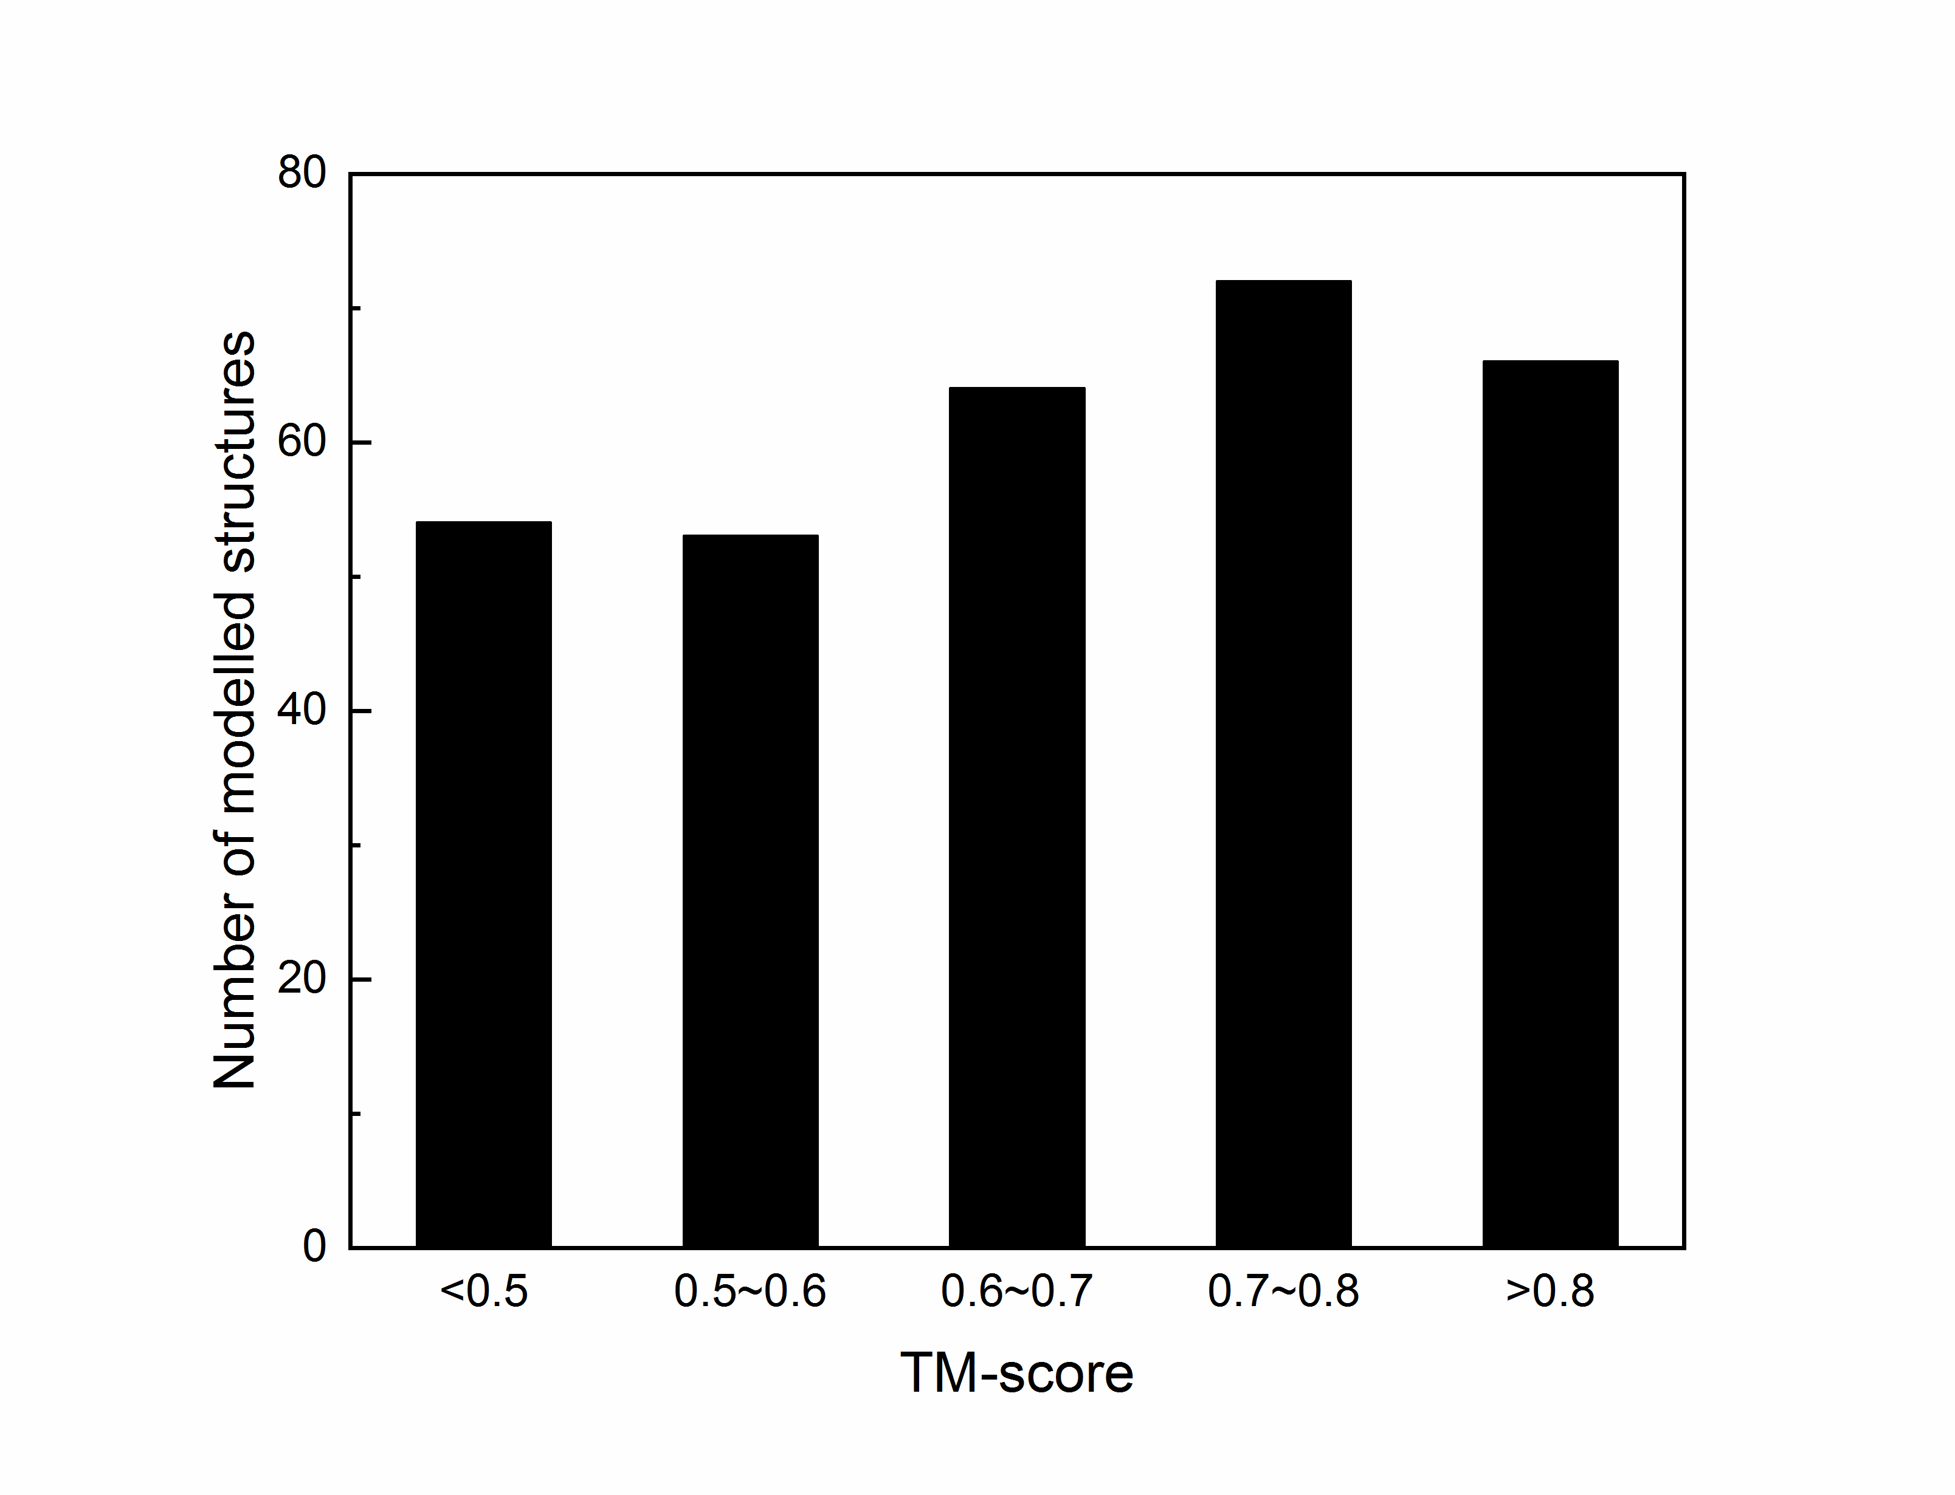
Figure S1. Distribution of TM-score values of the modelled structures from 309 protein chains in RB198 and RB111 datasets.

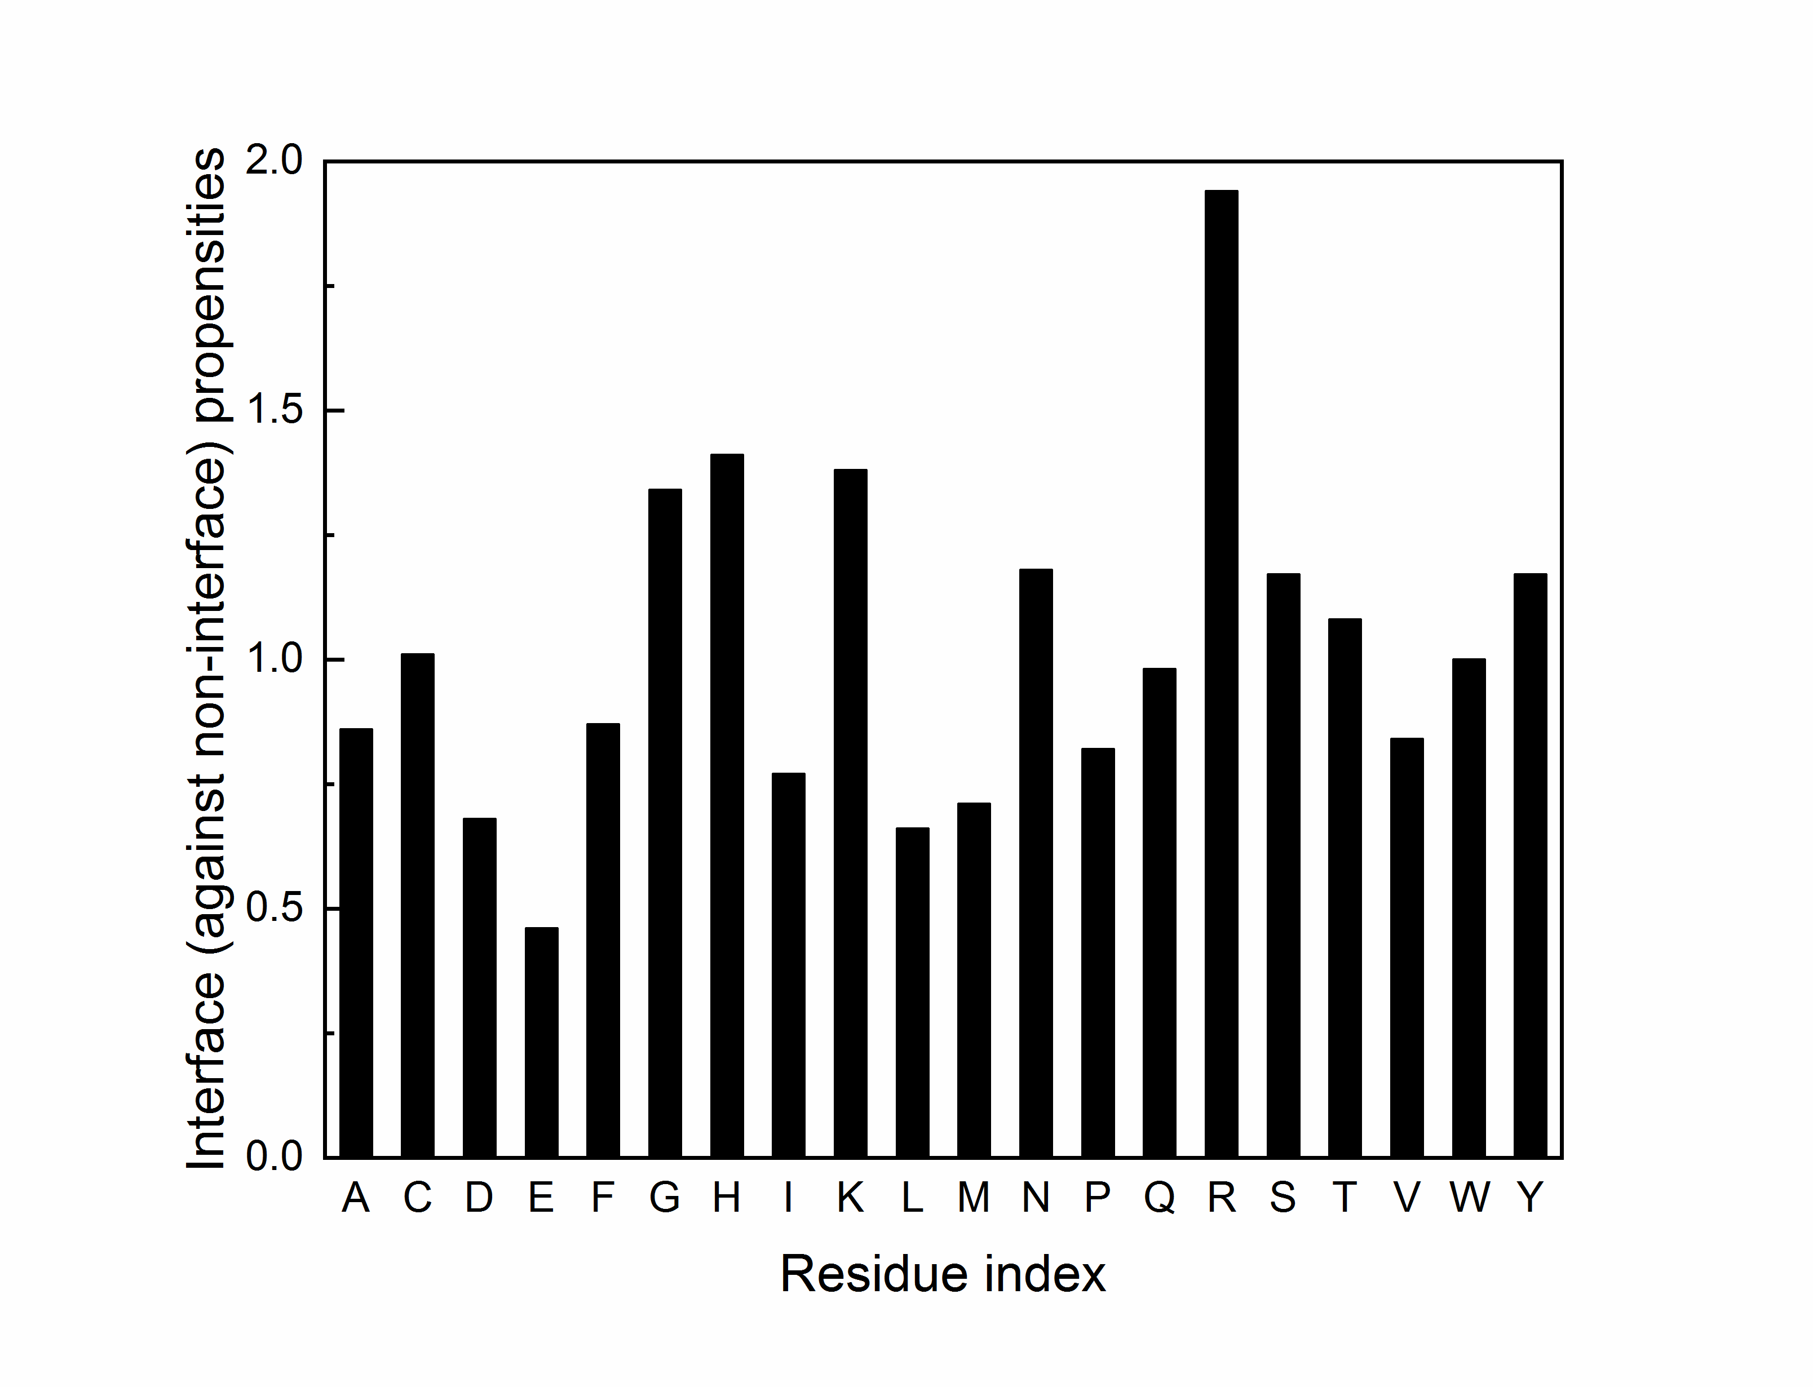
Figure S2. Interface (against non-interface) propensity of each kind of amino acids in RB198 and RB111 datasets, which is calculated from its observed probability at interfaces divided by its expected probability.
References:
[1] Peng H, Long F, Ding C. Feature selection based on mutual information: criteria of max-dependency, max-relevance, and min-redundancy[J]. IEEE Trans Pattern Anal Mach Intell. 2005, 27(8): 1226-1238.
[2] Yang J, Yan R, Roy A, et al. The I-TASSER Suite: protein structure and function prediction[J]. Nat Methods. 2015, 12(1): 7-8.
[3] El-Manzalawy Y, Abbas M, Malluhi Q, et al. FastRNABindR: Fast and Accurate Prediction of Protein-RNA Interface Residues[J]. PLoS One. 2016, 11(7): e158445.
[4] Walia R R, Xue L C, Wilkins K, et al. RNABindRPlus: a predictor that combines machine learning and sequence homology-based methods to improve the reliability of predicted RNA-binding residues in proteins[J]. PLoS One. 2014, 9(5): e97725.
[5] Wang L, Huang C, Yang M Q, et al. BindN+ for accurate prediction of DNA and RNA-binding residues from protein sequence features[J]. BMC Syst Biol. 2010, 4 Suppl 1: S3.
[6] Kumar M, Gromiha M M, Raghava G P. Prediction of RNA binding sites in a protein using SVM and PSSM profile[J]. Proteins. 2008, 71(1): 189-194.

